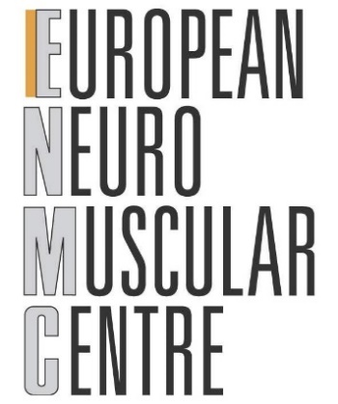
ENMC Early-Career Programme



ENMC Biographical Sketch (to be completed by candidates of the Early-Career Programme)

Name:
Position:
Education / training (Begin with academic degree or other initial professional education and include postdoctoral training, if applicable)
Institute and location | Degree (if applicable) | Year(s) | Field of study

1. EXPERIENCE:

Positions and employment
<please include an overview of your positions in the last 5 years>

Other experience and professional membership
<please include information on professional memberships and other relevant experience>

Previous experience at ENMC workshops
<if applicable, please include an overview of previous ENMC workshop experience as attendee together with the reference of the publication of the workshop reports>

2. PUBLICATIONS:

<please include up to 10 selected references of the last 5 years relevant to the current application>

3. Research support:

<please include information on relevant grant(s) supporting work currently being carried out by the applicant>
<please include possible sources for funding from your own network to support the applied workshop>

