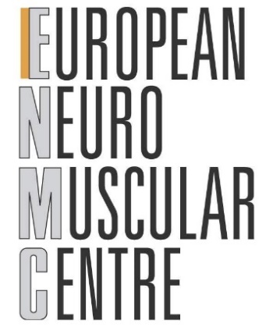
ENMC Early-Career Researcher
Application Form

In which ENMC workshop would you like to participate:
Workshop name: ______________________________________________________________
______________________________________________________________
Workshop number: ________________
Workshop date: ________________

Personal details
Name, surname: ______________________________________
Date of Birth: ______________________________________
Year of PhD: ______________________________________

Current affiliation: ______________________________________
City: ______________________________________
Country: ______________________________________
Phone: ______________________________________
Email: ______________________________________

Job title/role: ______________________________________
Date: ______________________________________
Signature: ______________________________________

Why is the topic of this workshop of relevance for your research a/o practice ? What do you expect to gain from this workshop?

How will your participation in this workshop contribute to your professional career?

Have you discussed and/or agreed upon your role(s) in the workshop with one of the organisers? What are you going to bring to the workshop?

